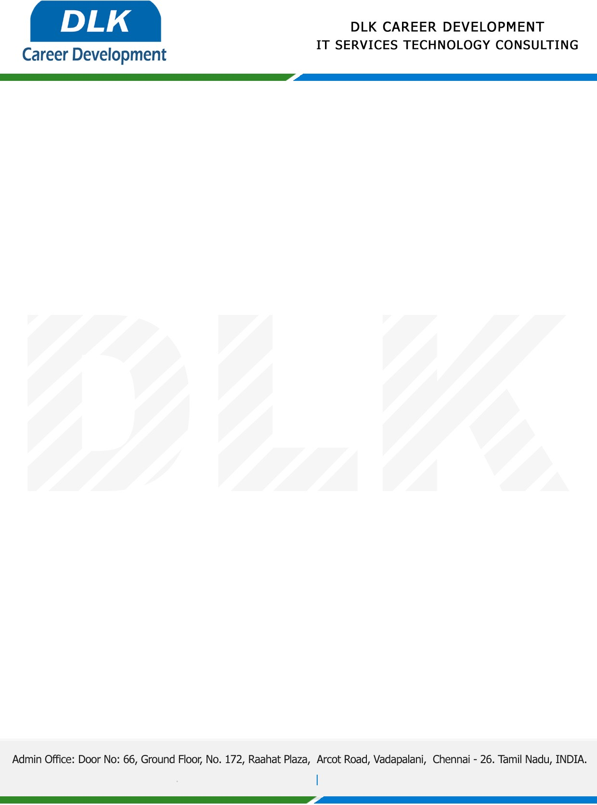

Date: 26 / December/ 2022

**To**

Department of BE – (Electronics and Communication Engineering ),

Head of Department,

Velammal Engineering College, Chennai-600066.

**Sub: Letter of Internship Acceptance**

This is to certify that **MS SONIYA T (REG NO: 113220041130)** that third year student of has accepted her Internship Work duration from **27th December 2022** to **16th January 2023** under domain **“Web Development”.** During the internship, all information and data collected from you should be kept confidential.

We appreciate your interest in **DLK CAREER DEVELOPMENT**

For **DLK CAREER DEVELOPMENT**

**HR Manager**

**VELMURUGAN J**